

**Minor Project Report**

**on**

**Project Title: -**

Quiz-Time: A Subject-Based Quiz Game

**Course: PROGRAMMIG METHODOLOGIES-LABORATORY**

**Course Code: CAP173**

|  |  |
| --- | --- |
| **Submitted by**  Mona Raj  Reg ID: 12417598  Section: D2404 | **Submitted to**  Ms. Anjana Sharma  Assistant Professor, SCA, LPU |

**Lovely Faculty of Technology & Sciences**

**School of Computer Applications**

**Lovely Professional University**

**Punjab**

# ****Title of the Project:****

Quiz-Time: A Subject-Based Quiz Game

# Problem Statement:

This project implements a subject-based quiz game in C. It allows users to choose a subject, answer five multiple-choice questions, and calculates their score. The program performs the following operations:

* 1. Displays subject choices and takes user input.
  2. Stores and retrieves subject-specific questions and answers.
  3. Matches user responses with correct answers.
  4. Computes and displays the final score.

# Objectives of the Proposed Project:

* 1. Develop an interactive quiz platform in C language.
  2. Allow users to select subjects and test their knowledge.
  3. Provide instant results based on user responses.
  4. Reinforce basic programming concepts like arrays, functions, and control statements.

# System Requirements:

* 1. **Front-End**: Command-line interface for user interaction.
  2. **Back-End**: C programming language.

## Flowchart/Algorithm:

* Prompt user to enter their name and choose a subject.
* Use a switch-case to load the corresponding quiz function.
* Display five questions; take and store user responses.
* Compare user responses with correct answers using a loop.
* Compute and display the final score.

## Input:

* User's name.
* Subject choice (1 for Biology, 2 for Mathematics, 3 for Computer).
* Responses to quiz questions (1-4 for each question).

## Output:

* Final score out of 5.

# Constraints:

1. The program supports only three subjects: Biology, Mathematics, and Computer.
2. Each quiz contains exactly five questions.
3. Fixed correct answers for each subject are pre-defined in arrays.
4. User responses must be integers between 1 and 4.

# Benefits of the Proposed Project:

1. Interactive platform for testing subject knowledge.
2. Simple implementation suitable for beginners learning C.
3. Helps reinforce programming fundamentals like arrays, loops, and functions.
4. Educational and entertaining for users.

# Expected Outcomes:

1. A functional quiz program that accepts user input and computes scores.
2. Accurate evaluation of user responses.
3. Improved user engagement through an interactive interface.

# Future Scope:

1. Add more subjects and questions.
2. Implement a graphical user interface for better interaction.
3. Store scores in a file for tracking progress.
4. Introduce a timer for added difficulty.
5. Support multiple users and maintain leaderboards.

# Coding Screenshots:

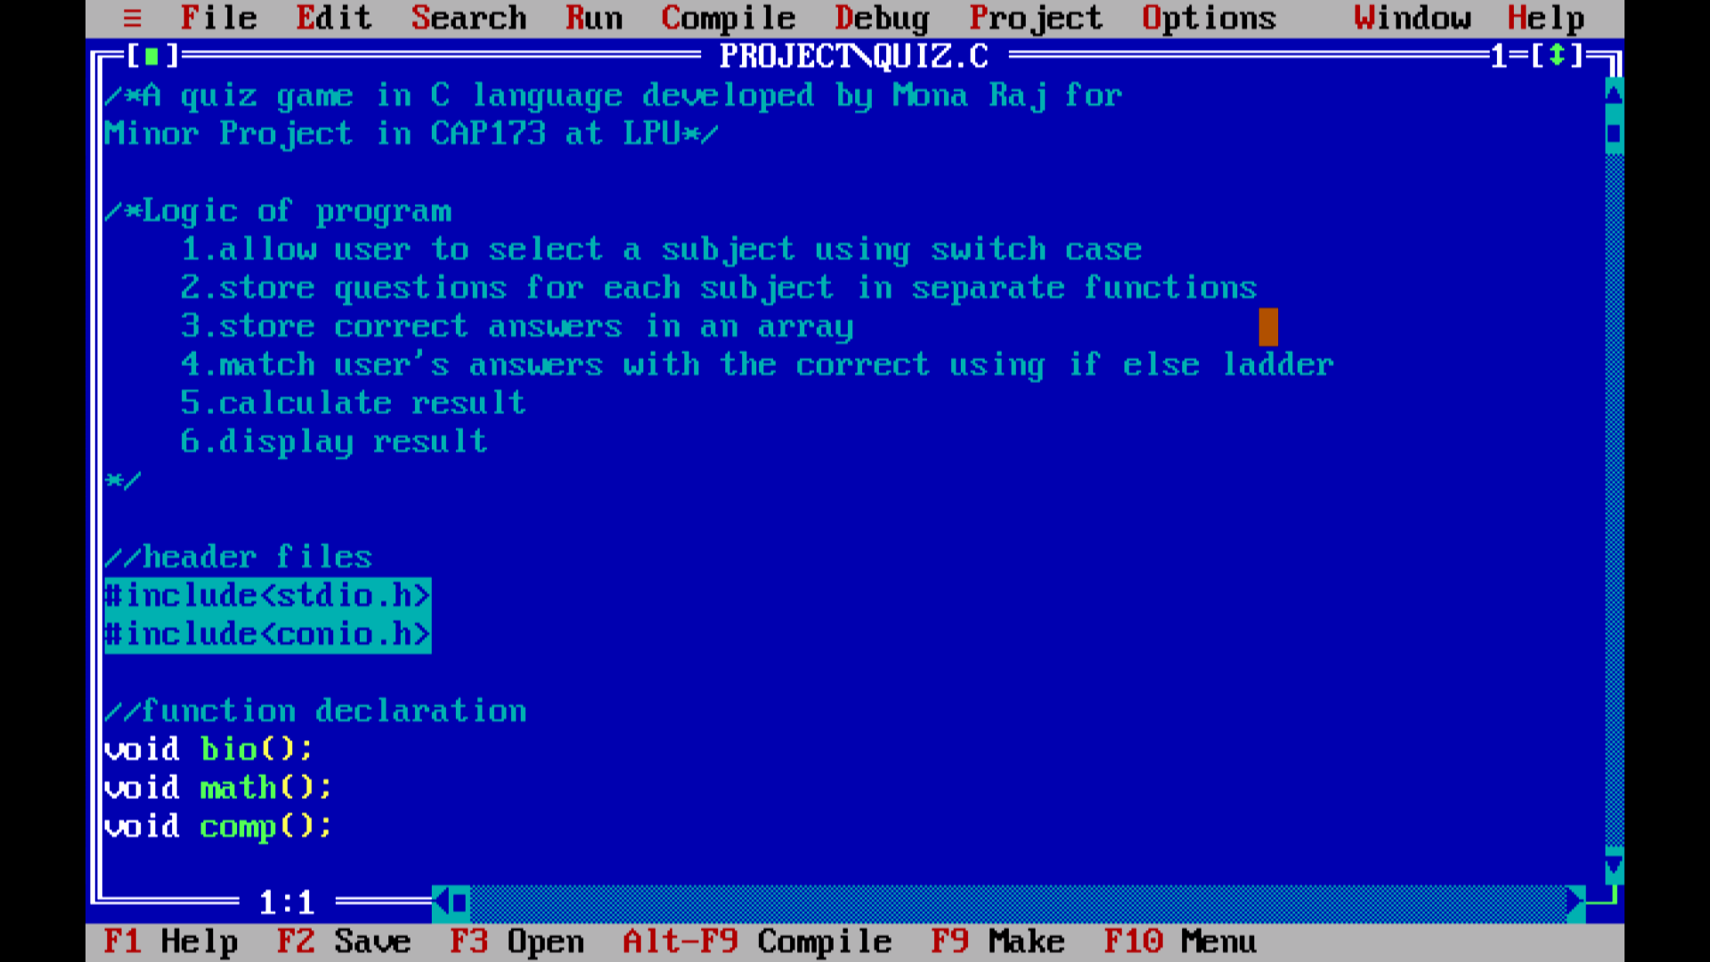

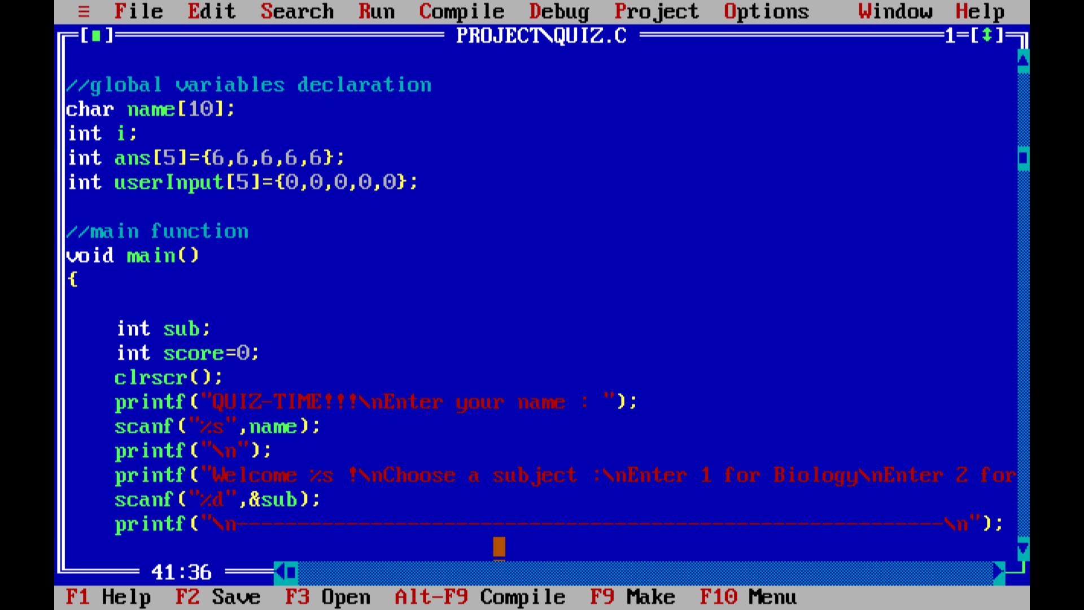

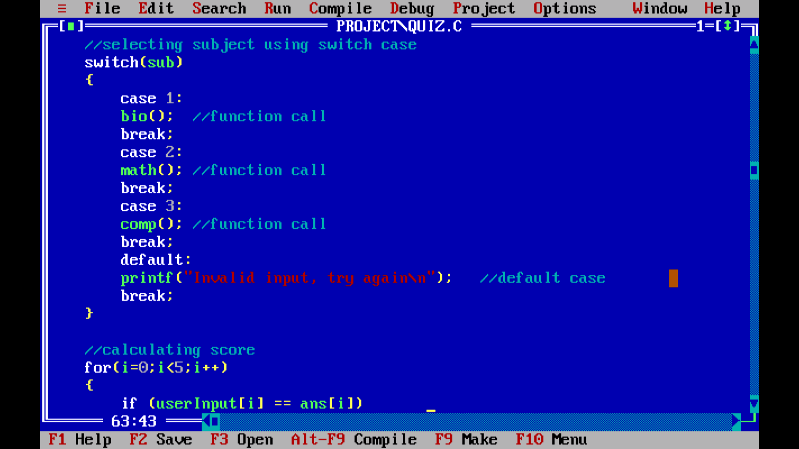

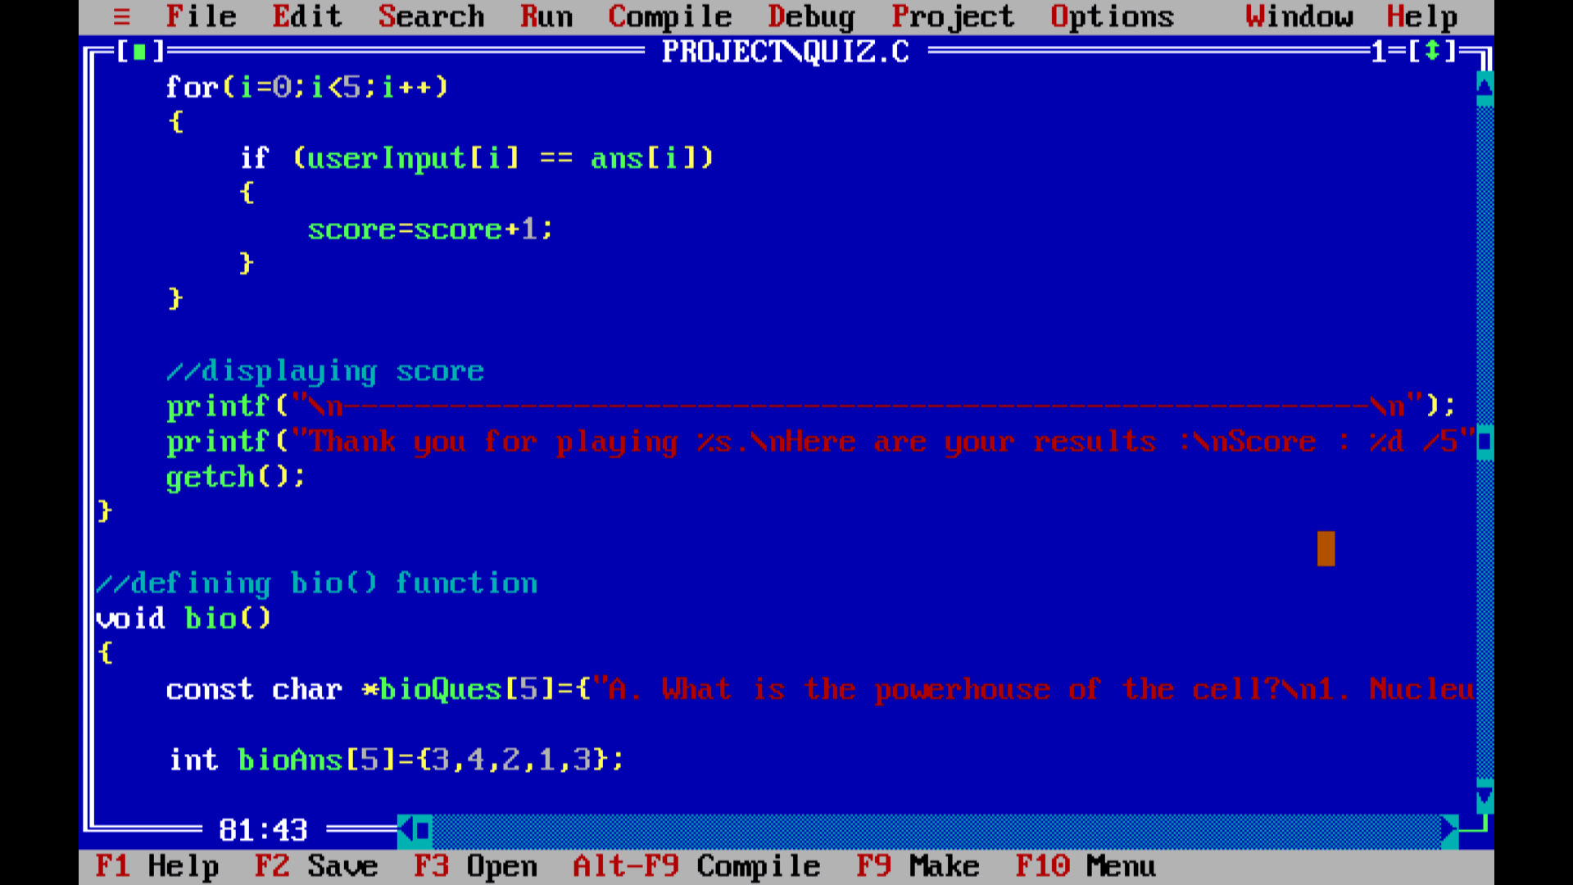

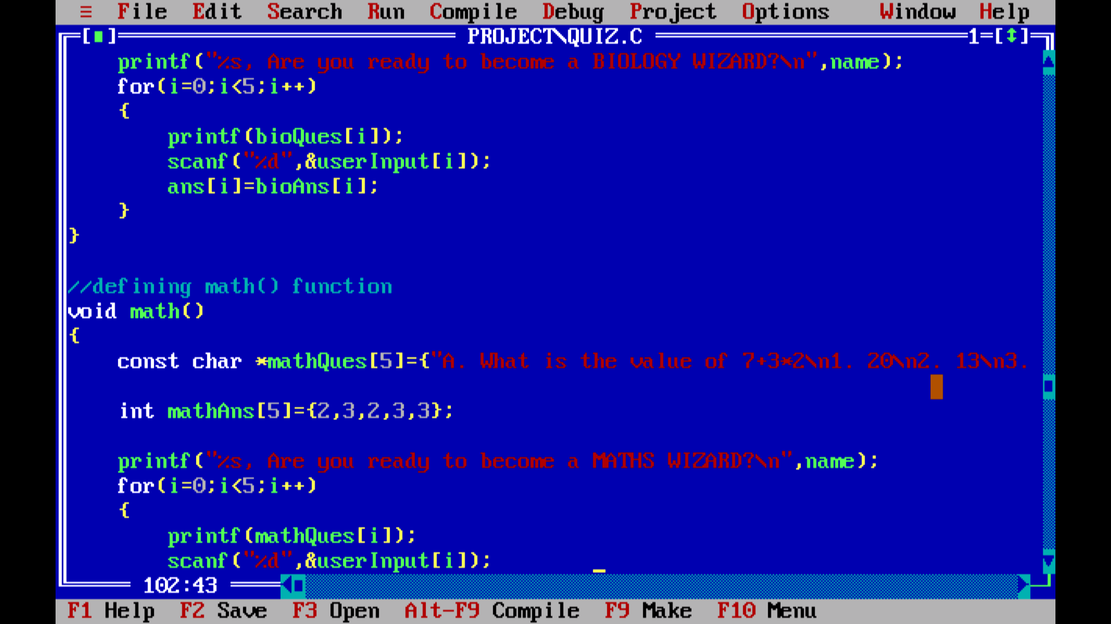

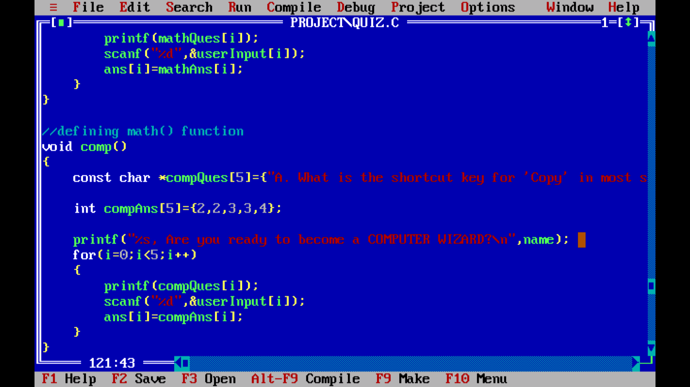

# Results screenshots:

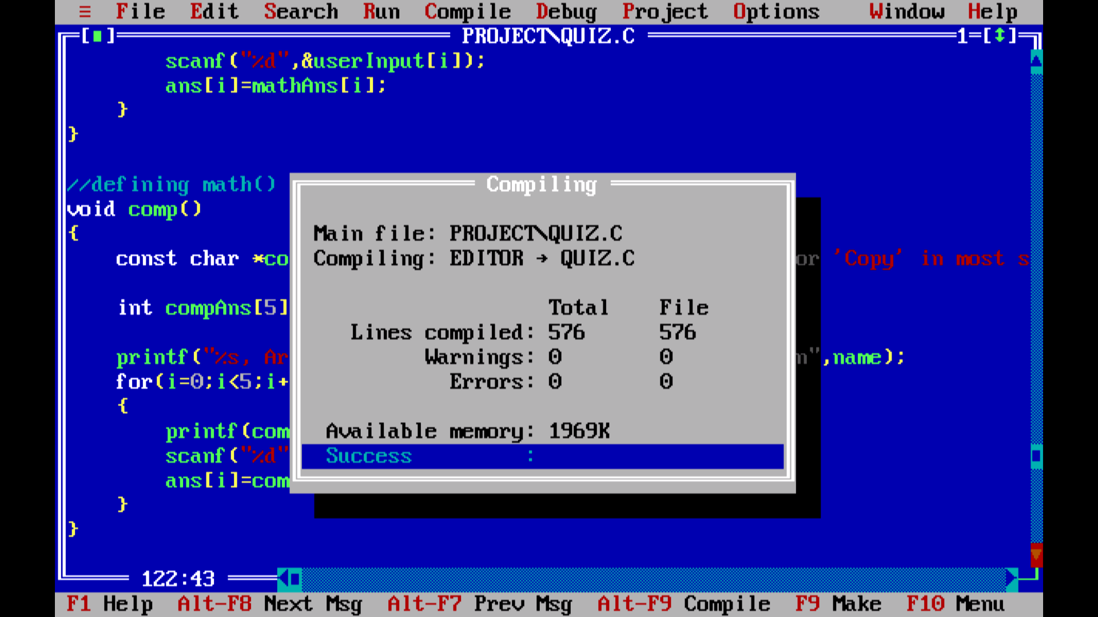

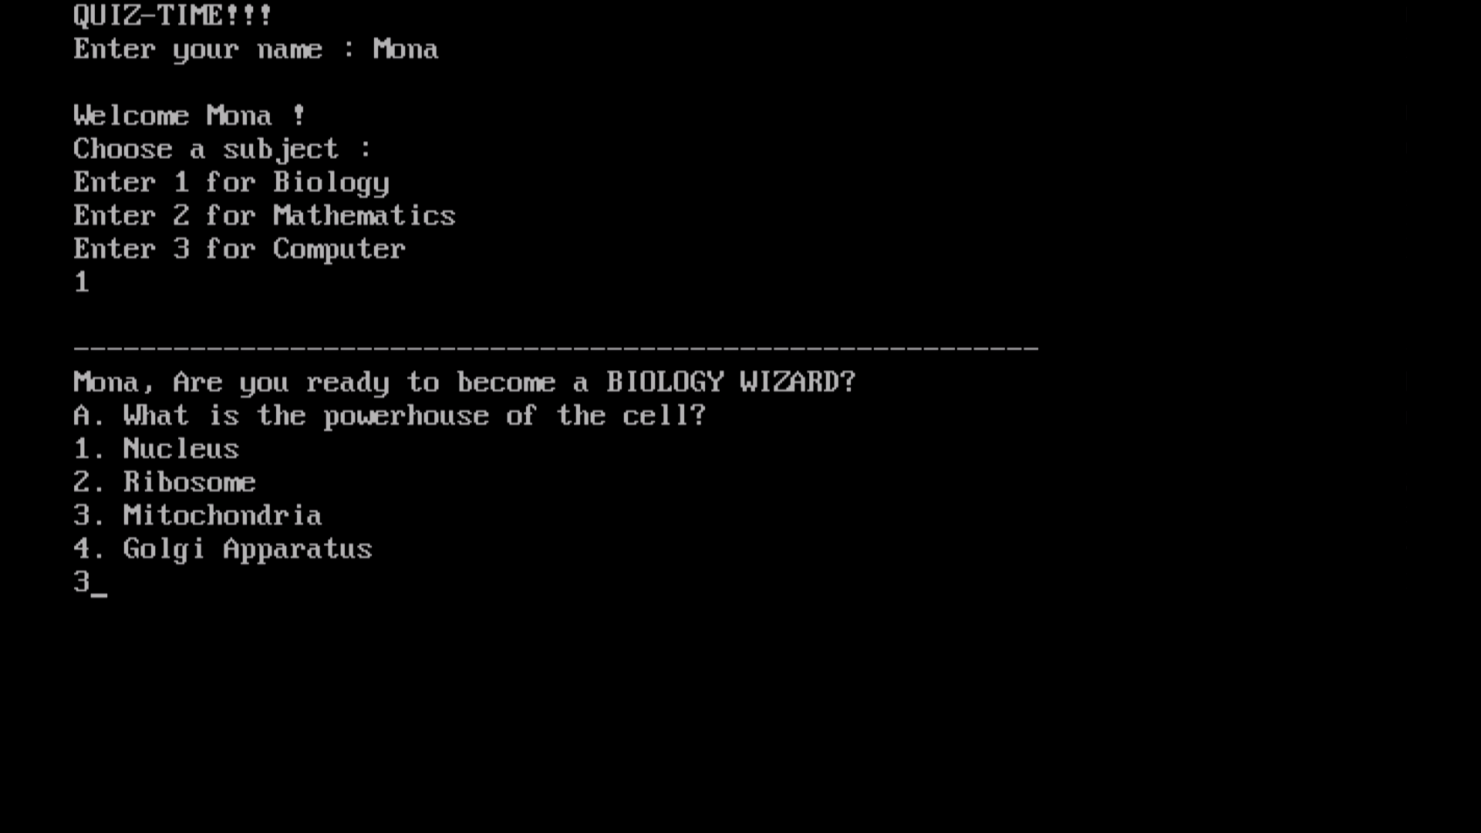

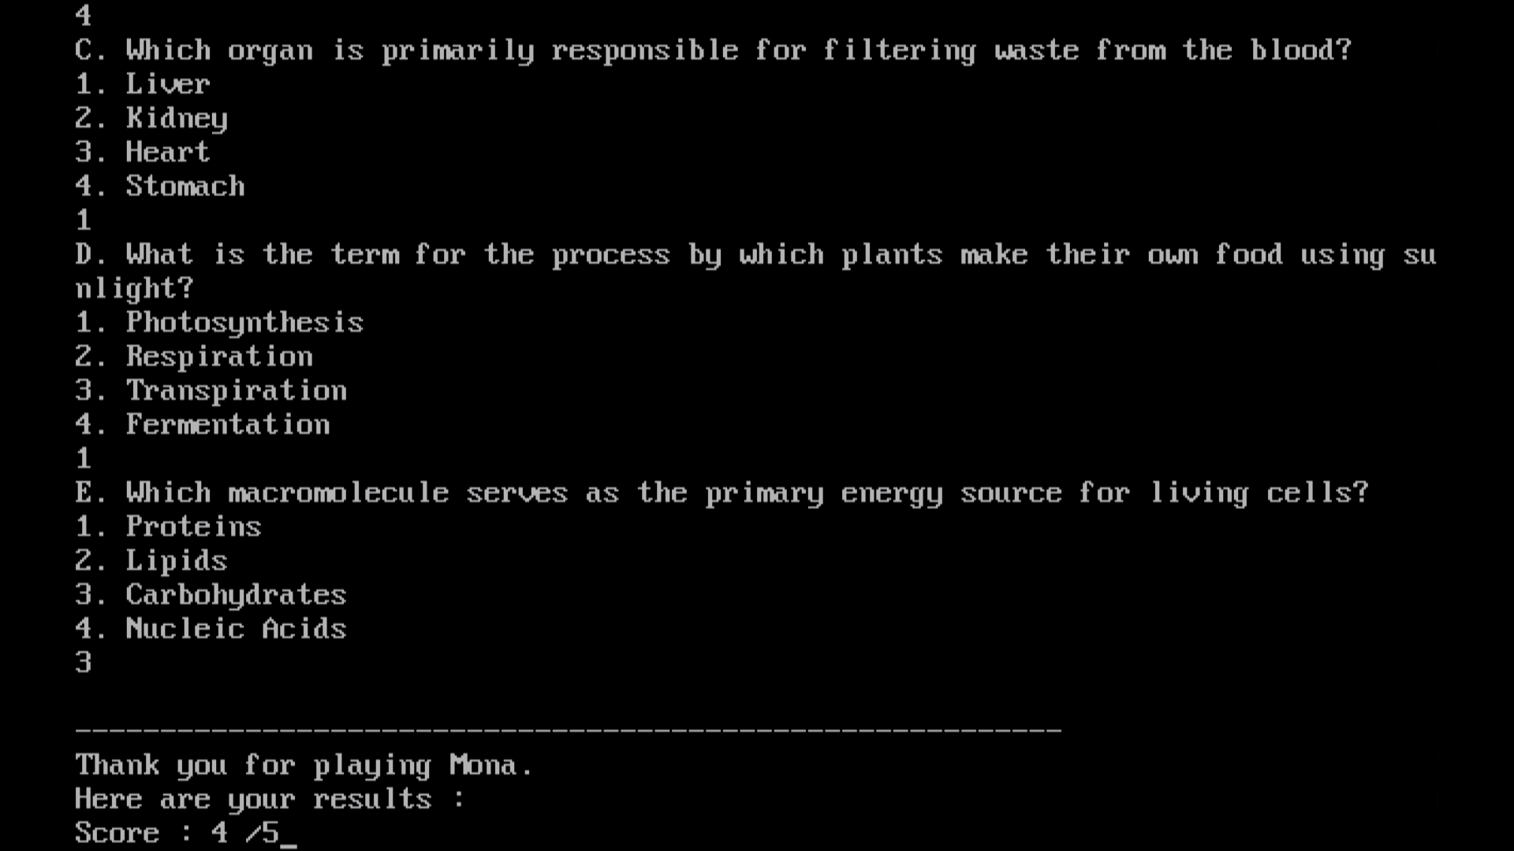

## Error Handling:

